**ASSESSMENT-1 CS – VIT**

NAME: Satrasala Nikhil Kumar

REG. NO. : 20BCY10169

**File and Directory Operations:**

ls: List files and directories

cd: Change directory

pwd: Print working directory

mkdir: Make directory

touch: Create an empty file

cp: Copy files and directories

mv: Move or rename files and directories

rm: Remove files and directories

find: Search for files and directories

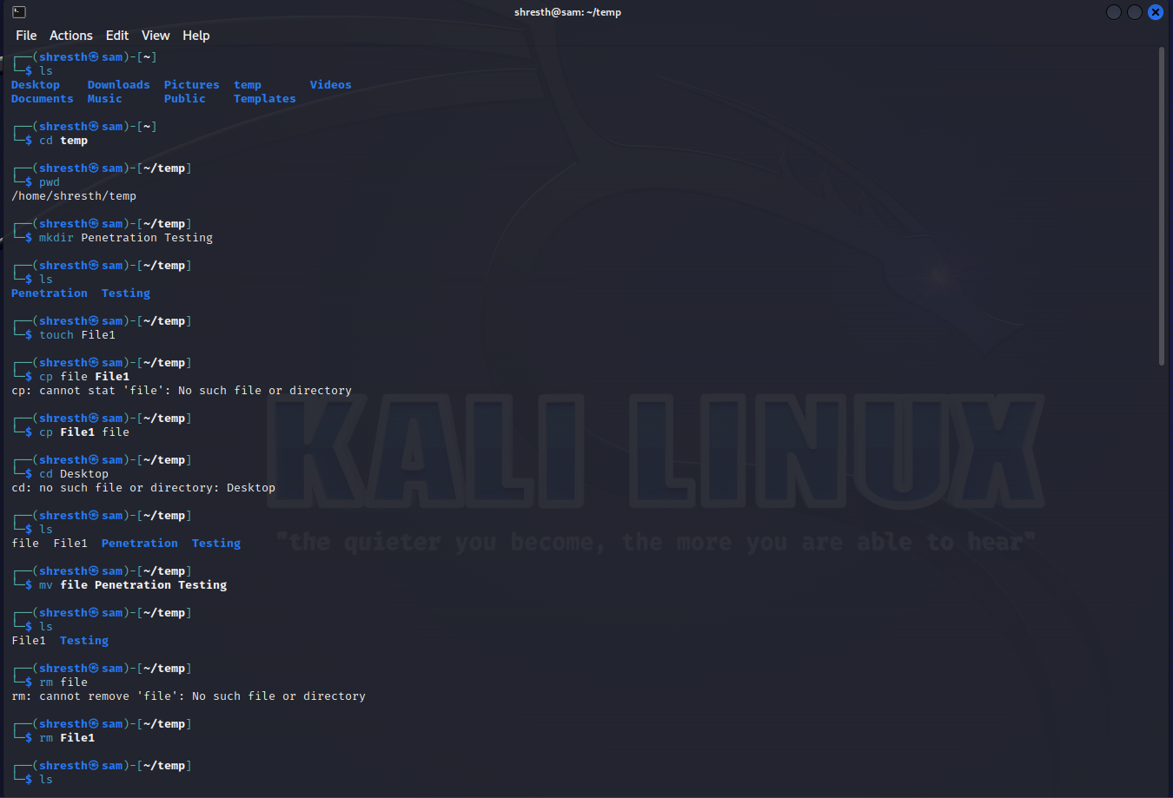

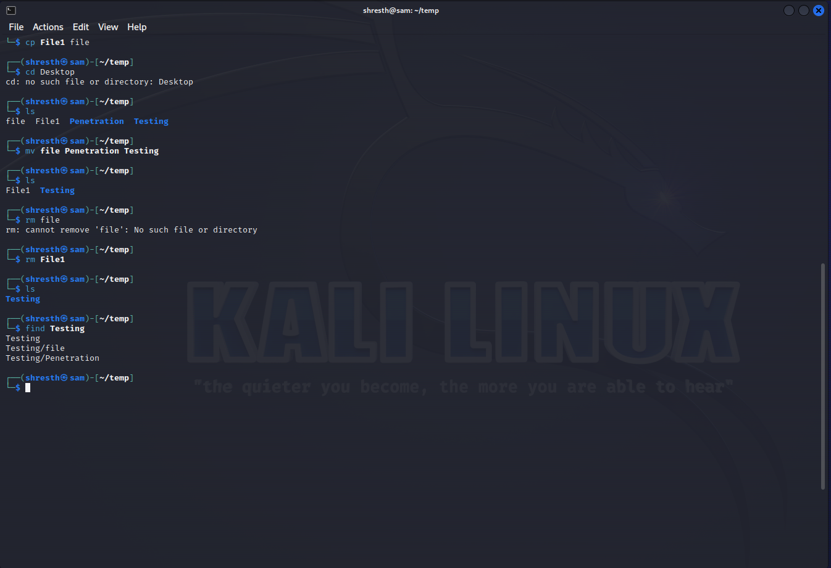

**File Viewing and Editing:**

cat: Concatenate and display file content

less: View file content with pagination

head: Display the beginning of a file

tail: Display the end of a file

nano: Text editor for creating and editing files

vi/vim: Powerful text editor for experienced users

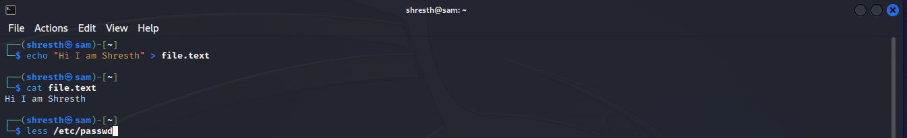

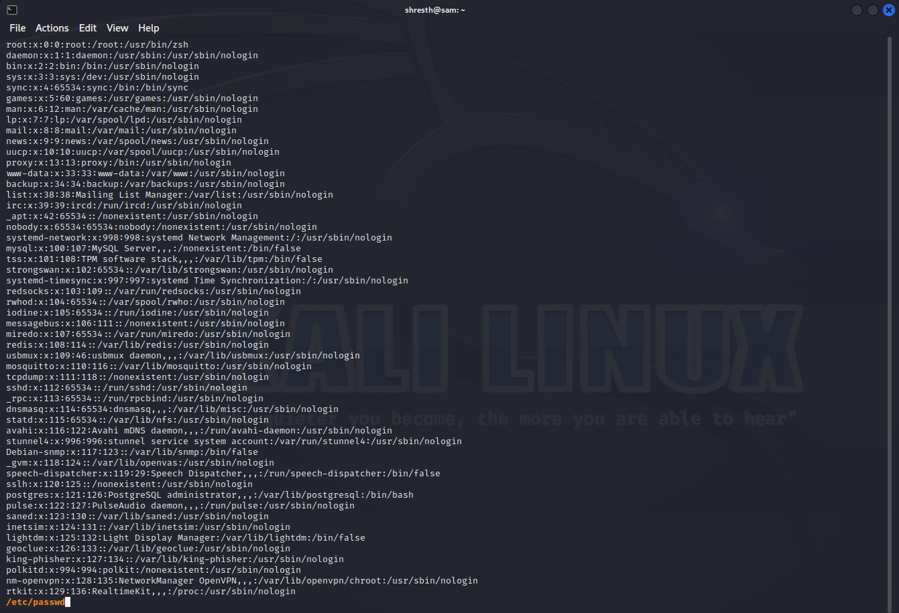

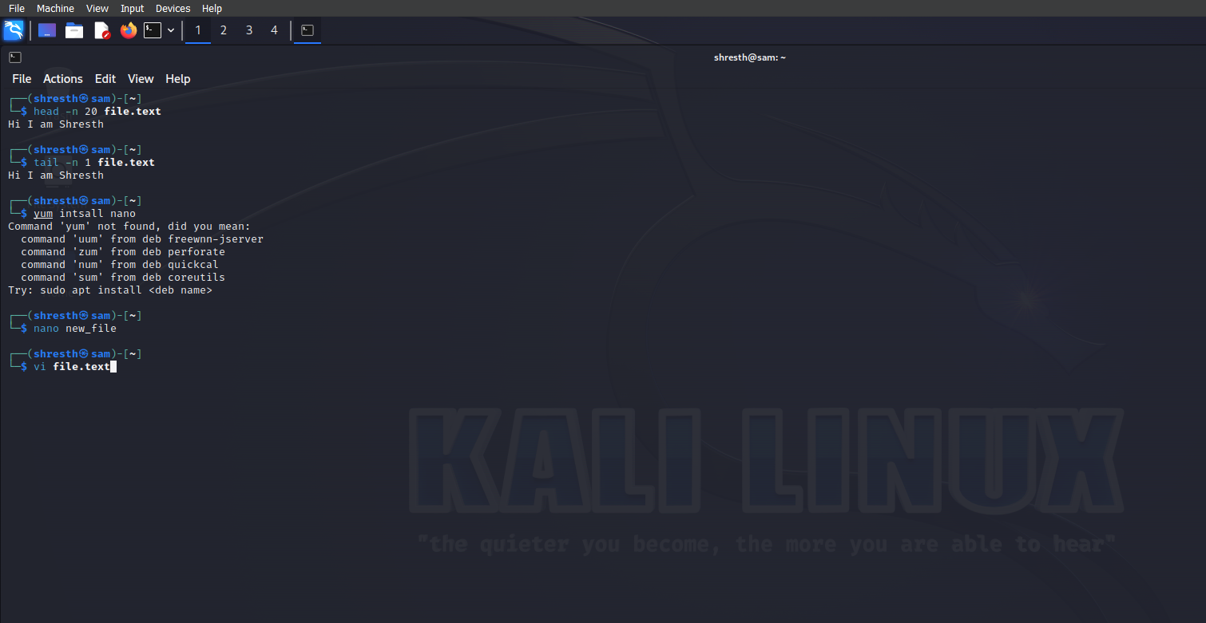

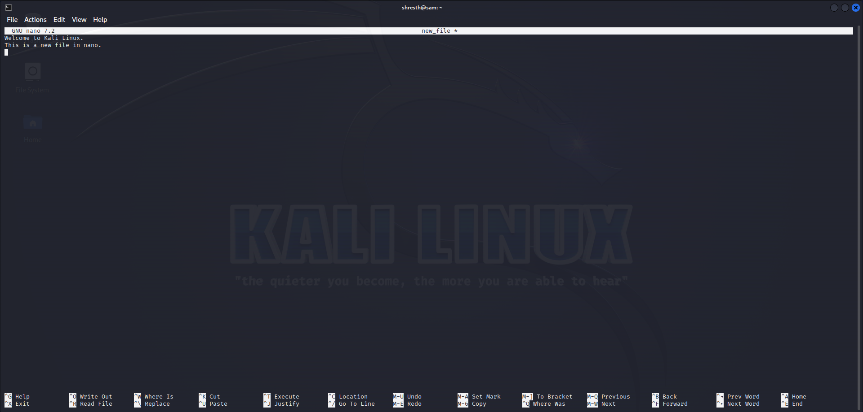

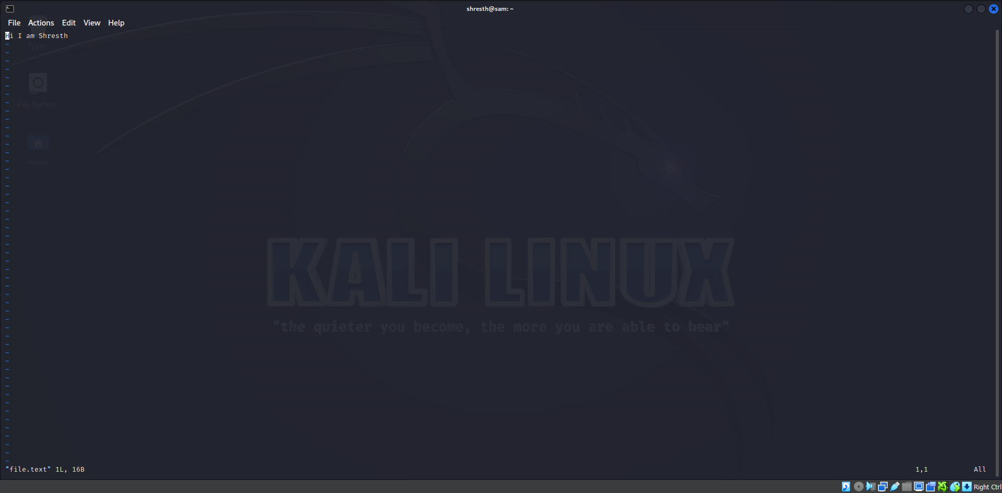

**File Permissions:**

chmod: Change file permissions

chown: Change file owner

chgrp: Change file group

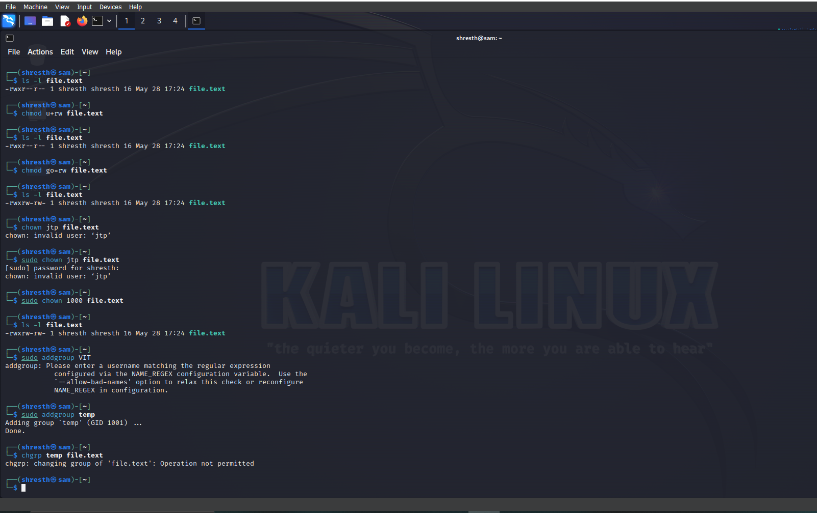

**File Compression and Archiving:**

tar: Archive files

gzip: Compress files

unzip: Extract files from a ZIP archive

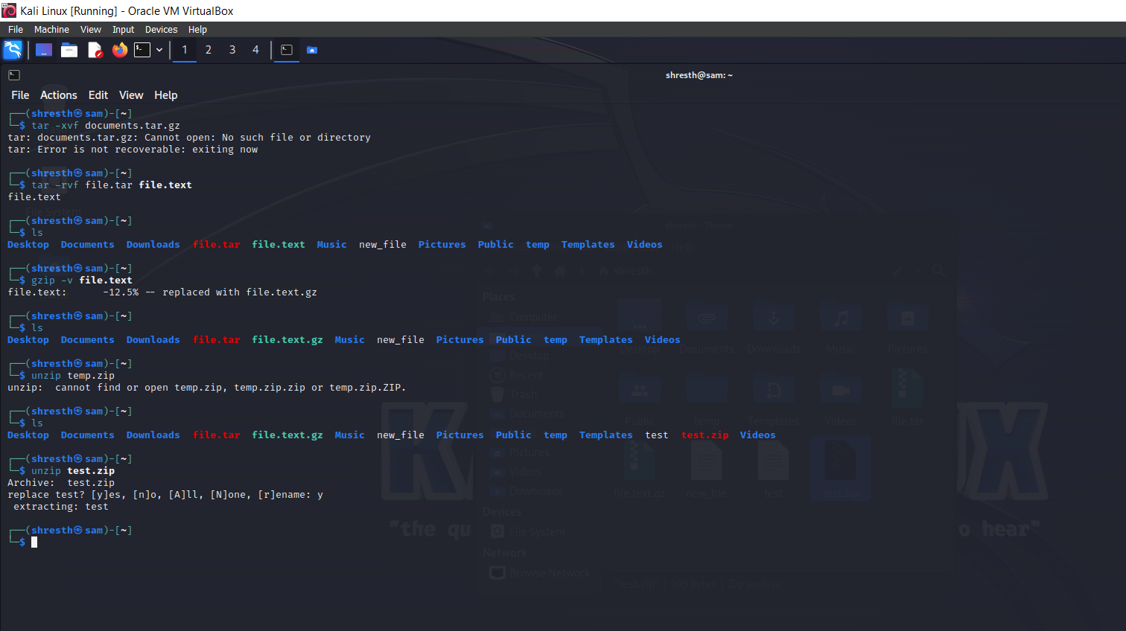

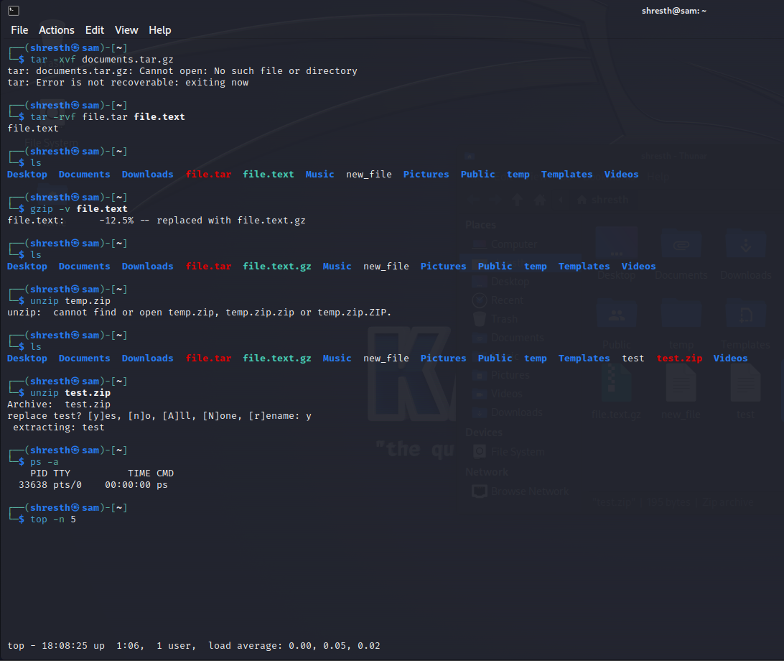

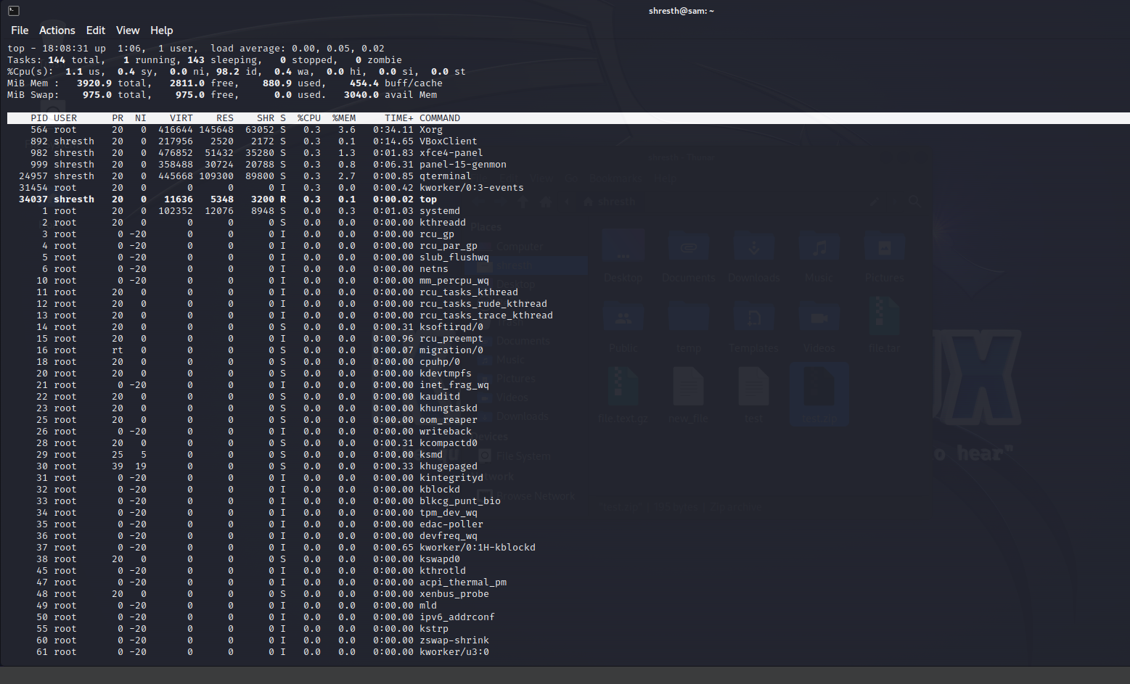

**Process Management:**

ps: List running processes

top: Display real-time system information and processes

kill: Terminate processes

bg: Run processes in the background

fg: Bring background processes to the foreground

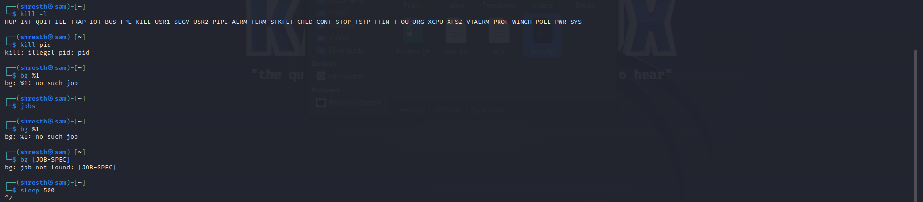

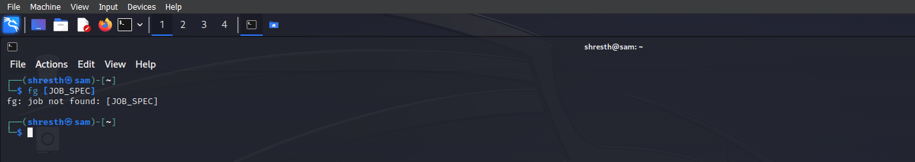

**System Information:**

uname: Print system information

df: Display disk space usage

free: Display memory usage

uptime: Show system uptime

who: Display logged-in users

w: Display logged-in users and their activities

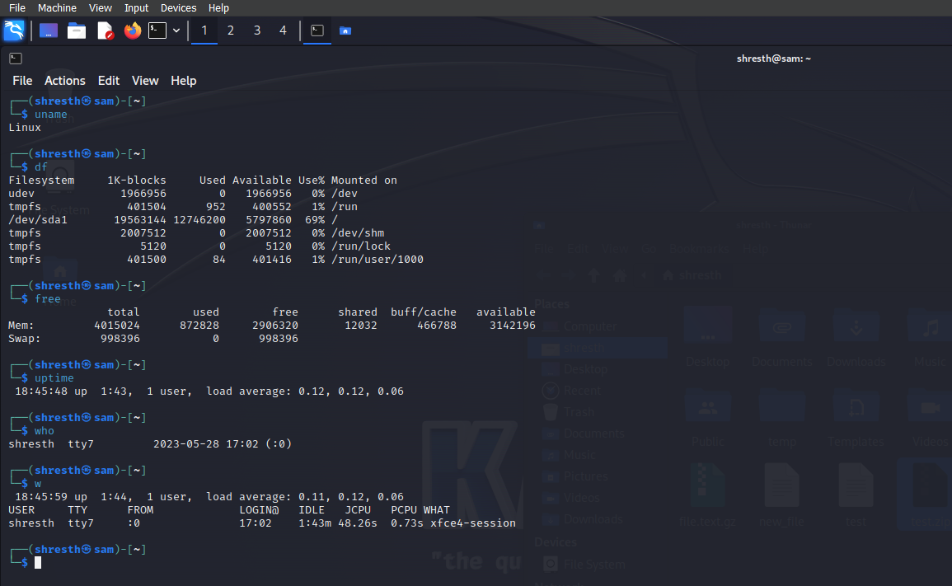

**Networking:**

ifconfig: Configure network interfaces

ping: Send ICMP echo requests to a network host

ssh: Securely connect to a remote system

scp: Securely copy files between systems

wget: Download files from the web

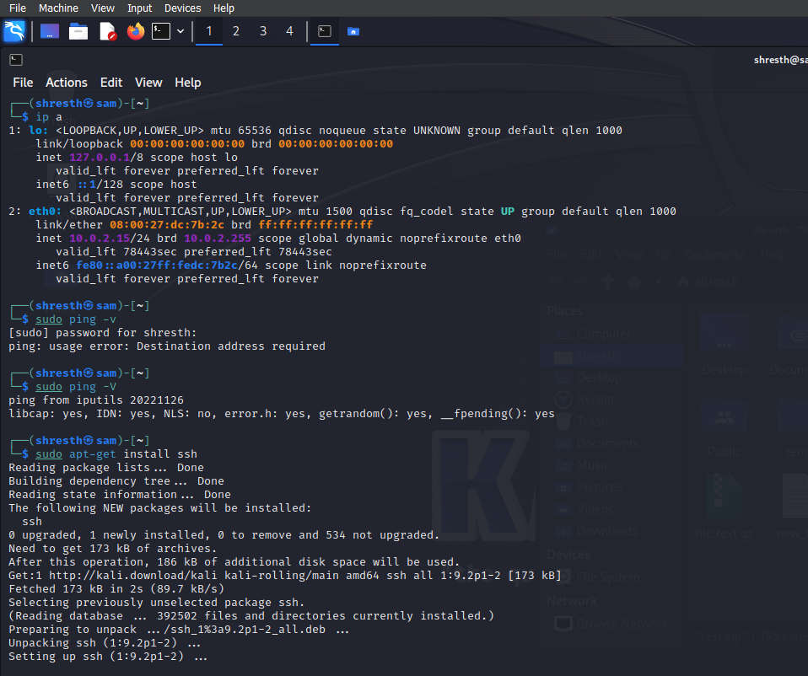

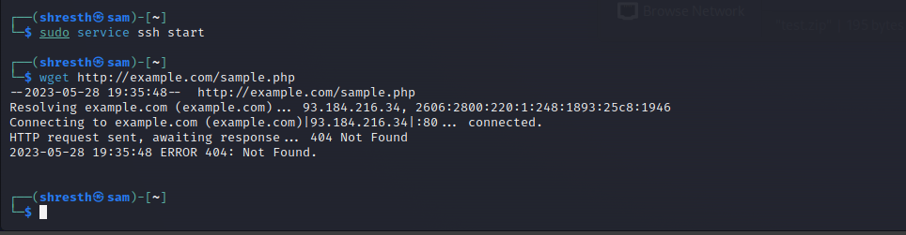

**System Administration:**

sudo: Execute commands with superuser privileges

apt-get: Package management for Debian-based distributions

yum: Package management for Red Hat-based distributions

systemctl: Manage system services

crontab: Schedule recurring tasks

useradd: Add a new user

passwd: Change user password

